***Chapter 2: Instructions and Operators:***

A C-program is a set of instructions. Just like a recipe - which contains instructions to prepare a particular dish.

**Types of instructions**:

1. Type declaration instruction

2. Arithmetic instruction

3. Control instruction

**Type of declaration instruction:**

int a;

float b;

other variations:

int i = 10; int j = i, int a = 2;

int j1 = a + j - i;

float b = a+3; float a = 1.1; ==>Error! As we are trying to use a before defining it.

int a,b,c,d;

a=b=c=d=30; ==> Value of a,b,c & d will be 30 each.

Copy

**Arithmetic Instructions**

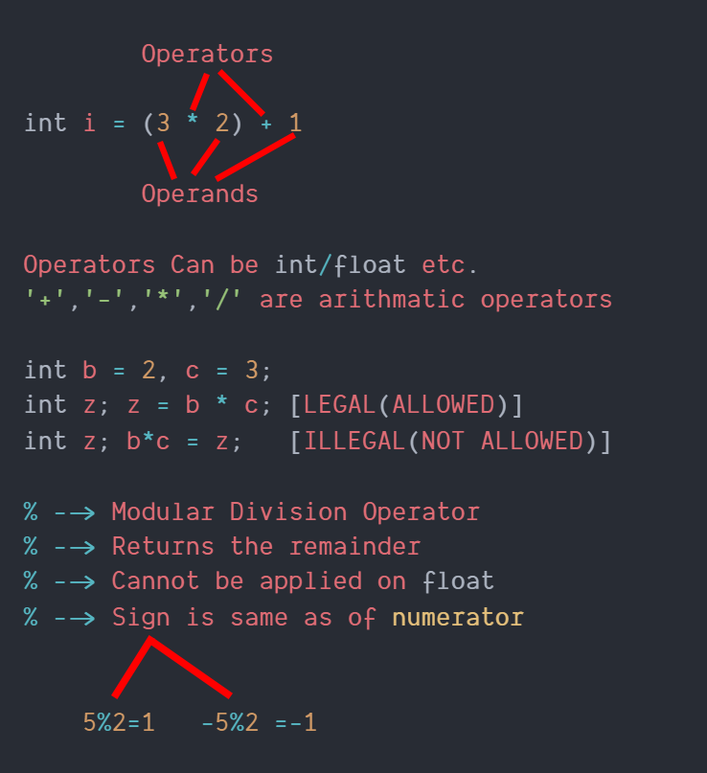

**Note:**

1.No operator is assumed to be present

    int i=ab  ( Invalid )

    int i=a*b  ( valid )

2.There is no operator to perform exponentiation in c however we can use pow(x,y) from <math.h>(More later).

**Type conversion**

An Arithmetic operation between

int and int ==> int

int and float ==> float

float and float ==> float

5/2 --> 2 5.0/2 --> 2.5 //IMPORTANT!!

2/5 --> 0 2.0/5 --> 0.4 //IMPORTANT!!

NOTE:

int a = 3.5; //In this case, 3.5 (float) will be denoted to a 3 (int) because a cannot store floats.

float a = 8; // a will store 8.0 [8-->8.0(Promotion to float)]

Copy

**Quick Quiz:**

**Question**- int k=3.0/9 value of k? and why?

Solution- 3.0/9=0.333, but since k is an int, it cannot store floats & value 0.33 is demoted to 0.

**Operator Precedence in C**

3*x-8y  is (3x)-(8y) or  3(x-8y)?

In the c language, simple mathematical rules like BODMAS no longer apply.

The answer to the above question is provided by operator precedence & associativity.

**Operator precedence**

The following table list the operator priority in C

|  |  |
| --- | --- |
| **Priority** | **Operators** |
| 1st | * / % |
| 2nd | +   - |
| 3rd | = |

Operators of higher priority are evaluated first in the absence of parenthesis.

**Operator associativity**

When operators of equal priority are present in an expression, the tie is taken care of by associativity

x * y / z => (x * y) / z

x / y * z => (x / y) * z

*, / follows left to right associativity.

Copy

**Control instructions**

Determines the flow of control in a program.

Four types of control instruction in C are:

1. Sequence Control Instruction

2. Decision Control Instruction

3. Loop Control Instruction

4. Case-Control Instruction

Chapter 2: Practice Set

**Q1**. Which of the following is invalid in c?

1. int a; b=a;

2. int v=3^3;

3. char dt= '21 Dec 2020' ;

Copy

**Q2**. What data type will 3.0/8 – 2 return?

**Q3**. Write a program to check whether a number is divisible  97 or not.

**Q4**. Explain step by step evaluation of 3*x/y-z +k

Where x=2, y=3, z=3 and k=1

**Q5**. 3.0+1 will be:

1. Integer
2. Floating number
3. Character